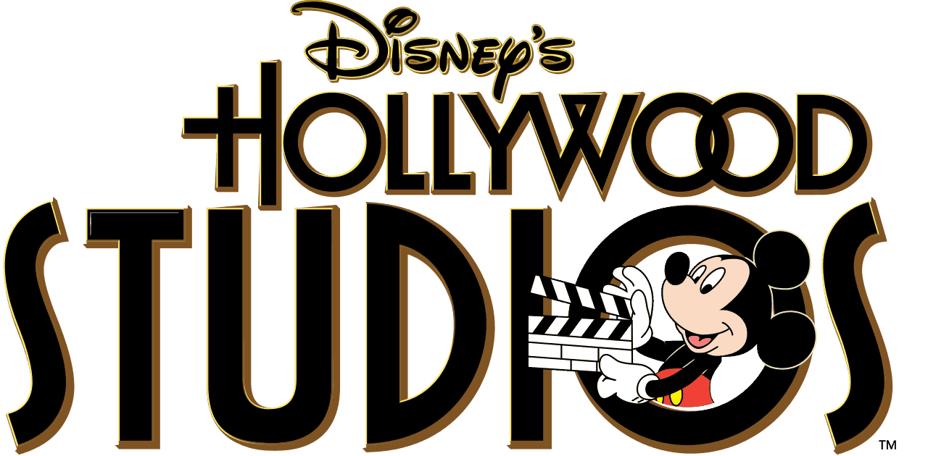
Today our trip takes us to Walt Disney World in Orlando Florida and Disney’s Hollywood Studios. Here is a list of some rides and shows for us to experience. Go to www.youtube.com and search for each of these rides/shows under Walt Disney World and the ride’s name. Example: Walt Disney World Toy Story Mania. When you are finished watching, write down which ride you like the best and why.

- Toy Story Mania 6. Star Tours
- Rise of the Resistance 7. Fantasmic
- The Great Movie Ride 8. Rock “n” Roller Coaster
- Muppet Vision 3D 9. Slinky Dog Dash
- Voyage of the Little Mermaid 10. Disney Junior Live on Stage

